JoV
In Lausanne, during the QPES 2023 conference, which took place on June 6th [https://qpes2023.sciencesconf.org/resource/page/id/11], Gilles Jacovetti presented a paper on project compostability and its application in higher education training. The theme of the colloque was the relationship between nature and education. In front of an audience of around twenty people, including teacher-researchers, educational advisors, educational department heads and deans, Gilles presented this concept in 15 minutes, based on a slideshow.
After the presentation, a question session followed, during which some interest was observed. However, it was clear that for some it was essential to see this approach in action in order to better understand its potential.
Two other speakers were part of the same symposium. The moderator concluded the debates by highlighting the deep notions common to the proposed approaches: the development of teaching skills.
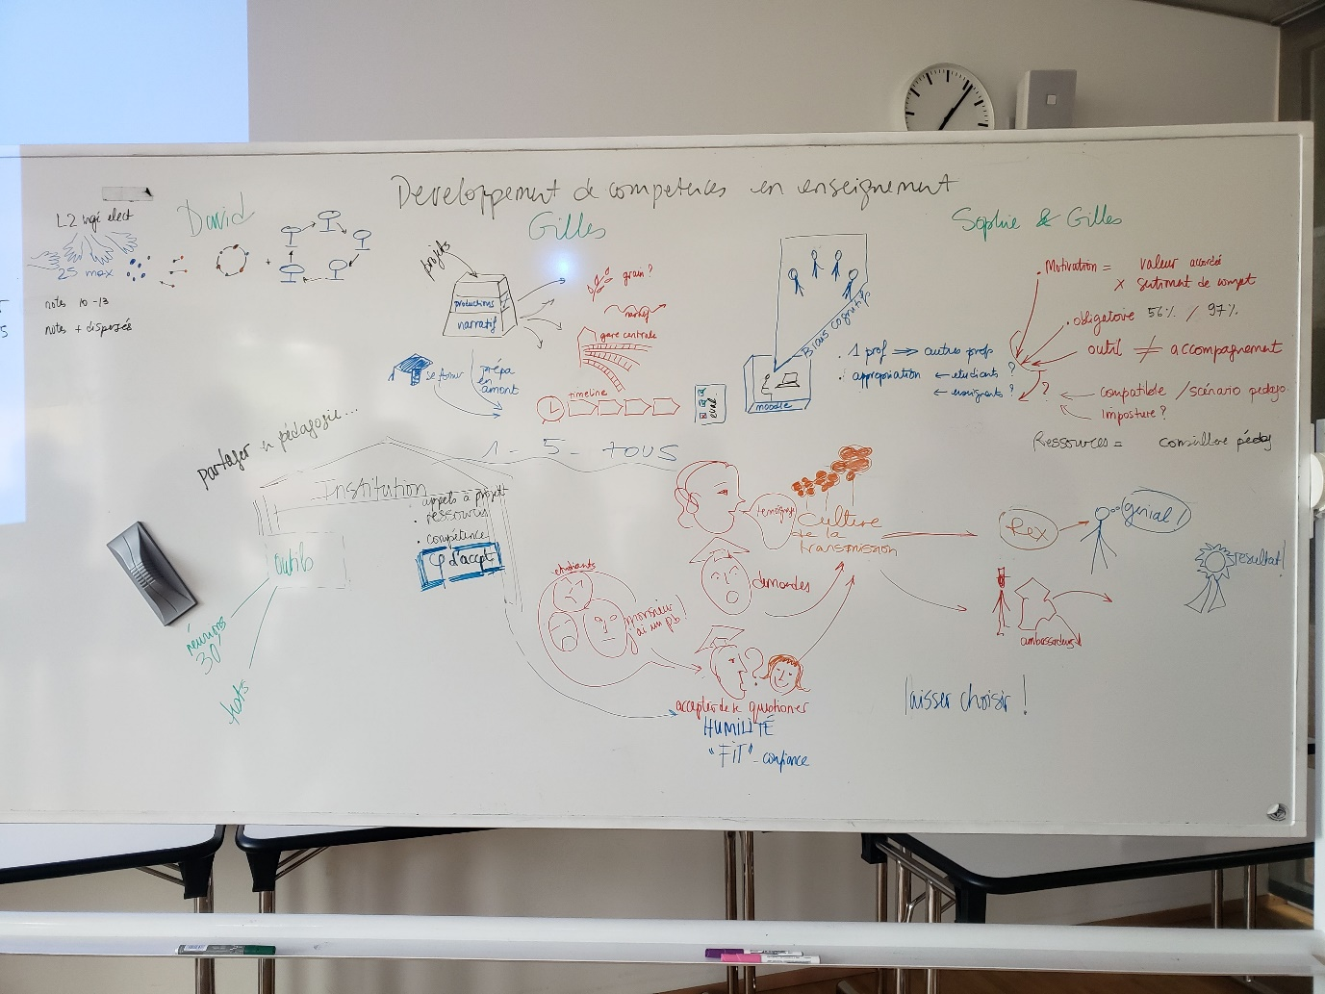
Following this intervention, two fruitful contacts were established, opening up new opportunities. A Malagasy teacher, showing keen interest, expressed his wish to implement this approach as part of a project. Also, a researcher specializing in educational sciences has invited us to present our approach at the next plenary meeting of her research team. This team is considering integrating compostability into one of their current projects, which could lead to an interconnection between their project's central station and that of DECART.
Finally, our colleague was also introduced to a university professor, an expert in the field of collaborative project traces, with whom he has a mutual relationship. This new contact could pave the way for joint initiatives regarding the practical implementation of project compostability, particularly in structuring the central station.

